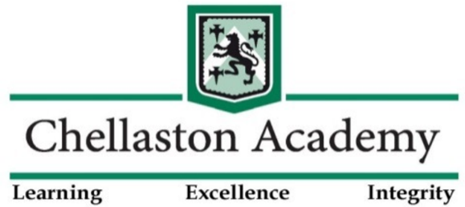
Admissions to Chellaston Academy

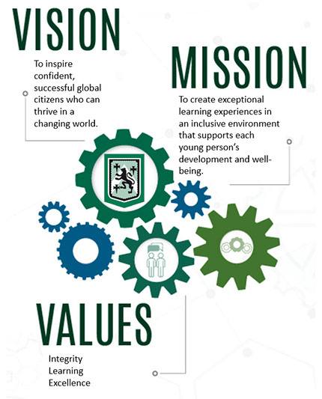
We are delighted that you are considering Chellaston Academy to be the Secondary school for your child. Together we aim to inspire confident, successful global citizens who can thrive in a changing world by focusing on both academic and personal development.
We are sad to not be able to offer an evening for you to visit during these times but we hope that there is some information we can share that can help you to make your informed choice.
If you have any further questions please email them to welcometoyear7@chellaston.derby.sch.uk by October 16th. We will then collate these and either reply individually or compile a list of FAQs for our website.

Important Dates

14 September 2020 - opening date for applications

31 October 2020 - closing date for applications. Any applications made after this date will be late and considered after all on time applications.

1 March 2021 – National Offer Day – If you applied online, you will be able to view your offer online from 1 March. You will be sent an email to the email address you use to register your account. For those who did not apply online, a letter is sent Second Class on this date, which can take up to a week to arrive. No decisions can be given over the phone.

How to Apply
When applying for a secondary school place you must apply through the council covering the area in which you live, which may not be the same as where the school is.

Derby City Council

Useful Links

- Derby City Council secondary schools admissions leaflet (pdf, 853kb)
- Derby City Council secondary schools admissions handbook (pdf, 724kb)

Applications can be made online at www.derby.gov.uk/secondary, this is the quickest and easiest way to apply. You can also apply by telephone on 01332 642727. Alternatively, you can download a paper application form and return it to us or request a paper application form to be sent to you using the same telephone number.

Derbyshire County Council
The information on DCC website parents' guide to secondary education can help you to choose a school and make an application.
Apply Online - For children transferring to secondary school in September 2021 you can apply online from 14 September 2020 until midnight on 31 October 2020 on the below link:
Make a secondary school application

Apply by telephone
You can make a telephone application through Call Derbyshire from 14 September 2020. Tel: 01629 533190 from 8am to 8pm Monday to Friday and from 9:30am to 4pm on Saturdays.

Catchment Area
Please see the Chellaston Academy Admissions Policy on our website, this will provide you with information regarding our catchment area and how places are allocated and the appeals process https://www.chellaston.derby.sch.uk/assets/admissions-policy-2021-2022.pdf.
Catchment Area Map – please see below the catchment area covered by Chellaston Academy. This can be enlarged to view.
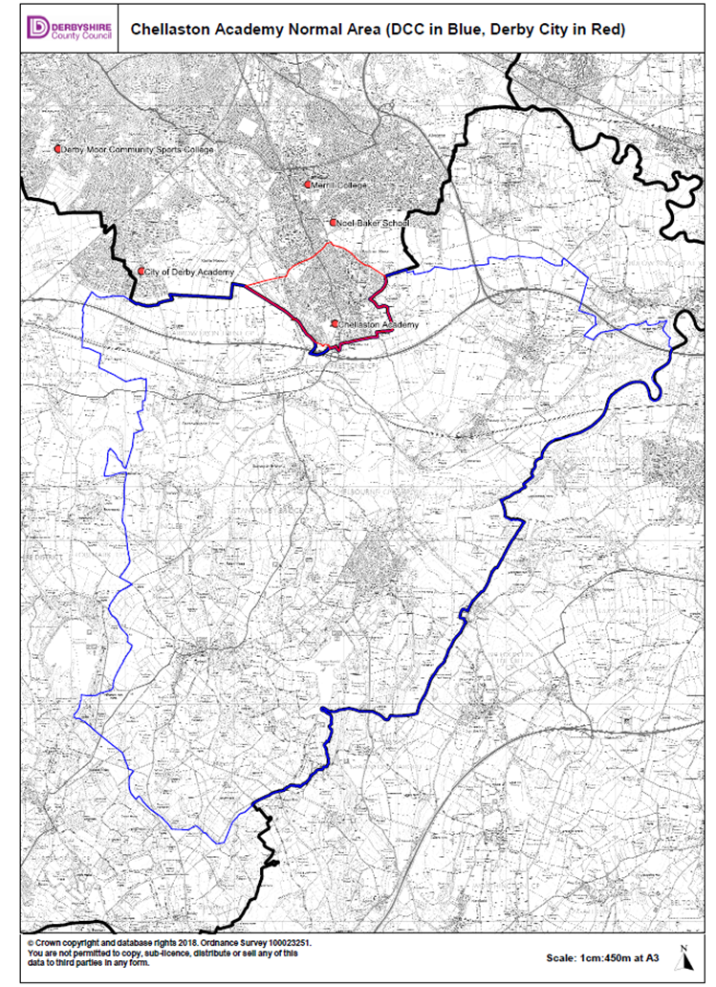
Curriculum and Teaching Sets
One of the most exciting things about coming to Secondary school is the range of new subjects and opportunities. In Year 7, students study the following subjects:
English/ Maths / Science
Art / Computing
Drama/ Music
Geography/ History
Modern Foreign Languages
Physical Education
Personal, Social and Health Education (PSHE)
Technology /Philosophy
Students are taught in their mixed ability form groups for all creative subjects (with a slightly different mixed ability grouping for Technology).
For core and Ebacc subjects, students are placed in teaching sets. Students are divided into two parallel half years, teaching and learning, and arranged into six ability sets within each half year. These sets will be based on an average of your child’s KS2 SATs scores for Reading and Mathematics. No teaching set will be larger than 30 students, with some considerably smaller.
In Year 7, students will study either French or Spanish as their Modern Foreign Language. This will be determined based on their teaching set and is not, therefore, something for which students can express a preference. However, in exceptional circumstances, a request from parents may be considered, although this cannot be guaranteed; in all cases, a child’s placement within the most appropriate teaching set will take precedent. Please note that we cannot accept requests based on the fact that your child’s sibling is currently studying a specific language. If you do feel that you have extenuating circumstances and wish to register a request, please contact Michelle Eley (MichelleEley@chellaston.derby.sch.uk) as soon as your child’s place at the academy has been confirmed.
If your child is working towards the expected standard for Year 6 students when he/she joins the academy, extra support will be put in place, including a differentiated curriculum in English and Maths. Students will have access to the Year 7 programme of study, whilst also studying to develop the skills that will underpin their progress throughout KS3 and KS4.
Pupil Premium
If your child is eligible to be part of the Pupil Premium cohort at Chellaston Academy, the link below will provide details of additional support and benefits that your child will receive:
http://www.chellaston.derby.sch.uk/pupil-premium.html
Please contact Lara Giles, Raising Standards Leader: Pupil Premium (LaraGiles@chellaston.derby.sch.uk), for further information.
For all other information such as further detail about our Uniform, The school day and our activities please see the Academy Website (we are excited to launch a new website very soon) or our social media Facebook page or Twitter handle @ChelloAcademy.
Thank you for reading this information.

