5th June 2026

Dear Parent/ Carer,

It has been a positive and purposeful start to the half term, with a great deal already taking place across the school.

We are incredibly proud that one of our students is currently involved in the RAMS programme in Kenya, a fantastic opportunity and a reflection of the ambition and global outlook we encourage at Chellaston Academy. Alongside this, it has been wonderful to see footballing success, with two of our students winning several medals at a tournament in Filey with their team Chesapeake Football Club, an excellent achievement plus many other fantastic stories to share.

In school, there has been a strong focus on key transition points. Our Year 12 students have taken part in their ‘Step Up’ assembly, helping them prepare for the challenges and opportunities of Year 13, while today marks the final day of teaching for our Year 11 students. We wish them every success as they move into the next stage of their examinations and thank them for the way they have approached their final year.

Looking ahead, a reminder that Year 7 Parents’ Evening will take place next week. This is an important opportunity to discuss progress and next steps, and we encourage all parents and carers to attend. Please ensure you sign up using your firefly log in.

Finally, a reminder to all students of the importance of a strong start to the school day students should be on site by 8.25am, ready for an 8.30am start.

Let us continue to build momentum this half term by maintaining the highest standards in attendance, behaviour and effort. As Aristotle reminds us, “We are what we repeatedly do. Excellence, then, is not an act, but a habit.”

Thank you, as always, for your continued support.

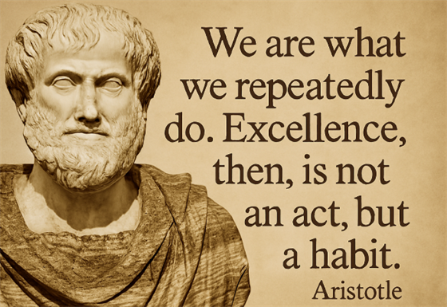

Year 7 Parents’ Evening - Thursday June 11th 4pm-7pm
This is the last parents’ evening of the year. A reminder to all parents, that there is no longer an early finish on a parents’ evening.
Last night, the booking opened for Year 7 parents’ evening. This morning, the percentage of bookings was at 70%, which is our lowest turnout of the year at this stage. We checked the World Cup fixture list and it was Mexico vs South Africa, so we can’t imagine it being a major distraction. Booking closes for this event on Wednesday night, so please get your bookings in via your Firefly log in.

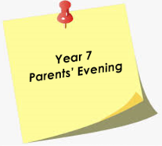
﻿
"Download" & School Buses
We are aware that the Download Festival traffic may have some impact on our school bus services. The traffic situation is always unpredictable. However, DCC Transport have informed us that from Wednesday 10th to Monday 15th June the bus timetables from Melbourne will be brought forward by 10 minutes.
A copy of the revised timetables are below. Please note that it may not be possible to stick exactly to these timings and all students should ensure they are at the nearest bus stop in good time.

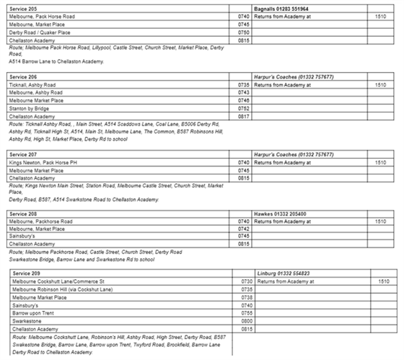

If your child's bus stop is within an area where the road is closed they should walk to the nearest one that is unrestricted.
Drop offs in the afternoon will follow the same pattern.

Year 10 Sexual Health Workshop
Our Year 10s had a Sexual Health Workshop on Tuesday with our local NHS team and were given the opportunity to learn even more about sexual health, local services and where to get help and support. Our pupils were fantastic with high levels of engagement and integrity and the delivering team praised them without exception.

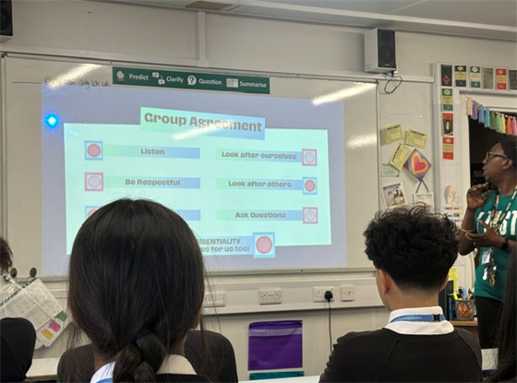

Year 10 Mock Exams
As we race through June, we'd like to send some reminders to our Year 10s for their mock exams from 15th to 26th June. Good luck Year 10!

Kit checklist
- Lanyard and ID card (lost ones can be ordered through Parentpay)
- Clear plastic pencil case
- Black pens
- Ruler
- Eraser
- Calculator
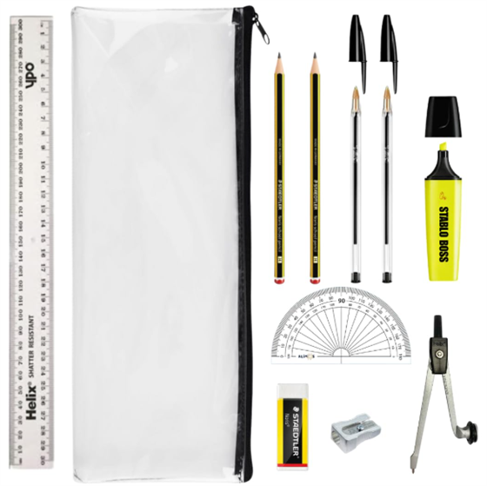

Derbyshire Fire Service - Fire Prevention
Our Key Stage 3 pupils will all receive an assembly on Thursday 11th June the Derbyshire Fire Service about Fire Prevention. This forms an additional part of our dedication to Personal Development and Safety. We look forward to the messaging they will receive and seeing how brilliantly they engage with our visiting speakers.



Year 11 Final Teaching Day
We are very proud of our Year 11s for taking all of the opportunities offered to them in the last few weeks and remind them that they are expected in for exams only from next week. They will need to go to DREF as usual for morning exams and sign out on paper sheets in reception through the front of school.
If they have any uniform or PE kit they'd like to donate to school it would be gratefully received in reception to be redistributed.
We wish them all the very best in these final couple of weeks and hope they have a fantastic Leaver's Day and Prom on 18th June.
Here's a cake made by Mrs Bola that she's shared around earlier today.

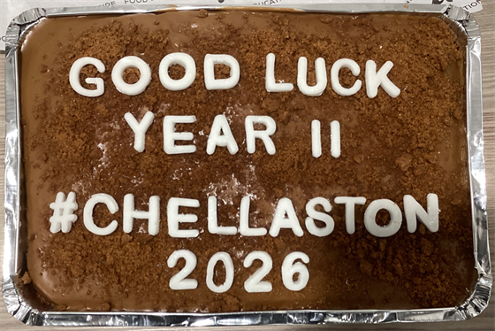
Scholastics Book Fair
We now have the Scholastics Book Fair in school from today with 3 book cases of books available for sale at the front of Main Hall and will be available at break and lunch every day next week.



Are you able to support our Year 10 Enterprise Day on Thursday, 2 July 2026?
We are looking for volunteers to share their professional experience and help students tackle an exciting challenge during the day. Your expertise could make a real difference — whether it’s guiding students in developing a business plan, working with numbers, or motivating a team to succeed.
If you’re able to offer your time — either for a few hours or the full day — we would love to hear from you. Please get in touch if you’re interested in supporting this event - Careers@chellaston.derby.sch.uk

Battlefields History Trip Information evening - Wednesday 10th June
On Wednesday 10th June between 5-6pm Mr Bevan-Brown will be holding an information evening for the parents of the students attending our upcoming Battlefields History trip. This will be an opportunity for parents to get all of the necessary information and insight into the details and rationale of this great experience for your young people. If you have any questions regarding this, please get in touch with Mr Bevan-Brown.

Year 12 Next Steps
On Thursday evening, the Sixth Form team welcomed Year 12 parents and carers to an information evening focused on students’ next steps beyond Sixth Form. With applications, career planning, and post-18 choices on the horizon, this is an exciting and important stage in our students' journeys.

The session explored the various pathways available after Sixth Form, including university and apprenticeships, and provided guidance on how families can support students as they begin making these important decisions. For those who were unable to attend, the presentation slides and UCAS Parents’ Guide have been emailed to all Year 12 parents and carers.



Duke of Edinburgh Gold Award Celebrations at Buckingham Palace
HRH The Duke of Edinburgh Gold awards took place in the gardens at Buckingham Palace 22nd May with 2,000 young people collecting their awards and DofE Leaders were invited for the 70th celebrations too. Mrs Weaver in her role as Duke of Edinburgh Manager at Chellaston Academy, had the rare experience of attending the celebrations this year, the sun was shining all day and it was a wonderful experience.
The Buckingham Palace Garden had been transformed into a festival-style celebration for the young people and their loved ones, with giant deckchairs, bunting, and activities – including some very special touches in recognition of the DofE charity’s 70th anniversary. There were a number of speeches at the main celebration stage from The Duke of Edinburgh Prince Edward, the presenter and author Jake Humphrey, and DofE Silver Award holder, Dame Kelly Holmes MBE OLY
At Chellaston we celebrated some of our students who started their journey at Chellaston completing their Bronze and Silver Award through school and then went on to complete Gold through Scouts. Well done to George S, Isabelle H, and Charlie H. We also have a number of Year 12 students and previous students that are taking part in their Gold award through scouts this summer.
To all the students that are currently on their own DofE journey, keep going keep adding the evidence and get the assessors to write the reports. It would be lovely to have you complete the award before the summer holidays.
To the students leaving us in Year 11, it's worth changing the email on your DofE account so you can get the update emails and there is time after your exams to complete the award.
Please contact Mrs Weaver at c.weaver@chellaston.derby.sch.uk so she can help you complete your award.


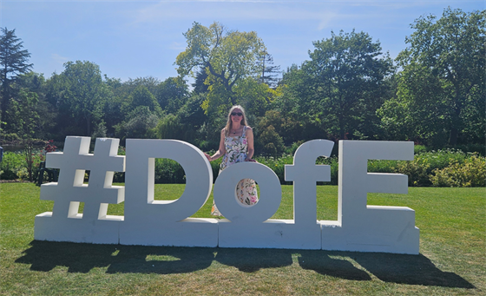

Jambo from Kenya
One of our wonderful Year 12 students, William A, has recently returned from an incredible two-week volunteering trip to Nakuru, Kenya, where he worked at St Trizah School as part of a team of 81 volunteers organised by Derby County Community Trust and African Adventures. After raising over £5,800 through a range of fundraising activities, William travelled to Kenya carrying donations of essential items including backpacks, clothing, toys, stationery and toiletries for the children. During his time at the school, he helped paint classrooms and toilet blocks, repair facilities, organise books for pupils, prepare meals for more than 100 children and staff, and even painted a large periodic table in one of the classrooms. William also supported teaching and helped distribute donations to the children. Alongside the volunteering work, he experienced some of Kenya’s most famous landmarks and wildlife, including a safari, the Great Rift Valley and the Giraffe Centre. This life-changing experience not only made a real difference to the local community but also demonstrated William’s commitment, compassion and willingness to help others. We congratulate William on this remarkable achievement and are incredibly proud of the positive impact he has made. Well done, William!
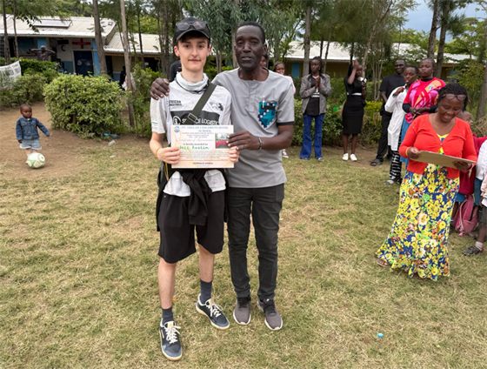

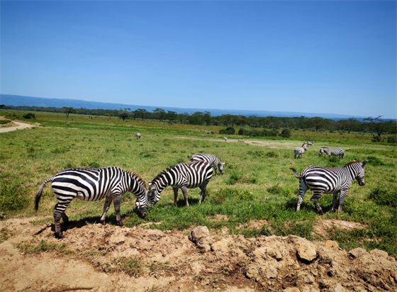

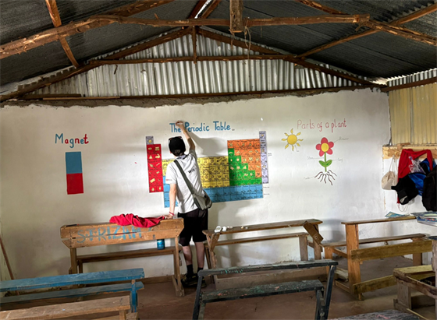
Year 7 Students in Filey Cup Tournament
Over the half term Natalie B and Eva P in Year 7 travelled for 3 hours and took part in the national Filey Cup tournament with their team and WON on the first day and came RUNNERS UP on the second day - Well done girls, we're very proud of you.

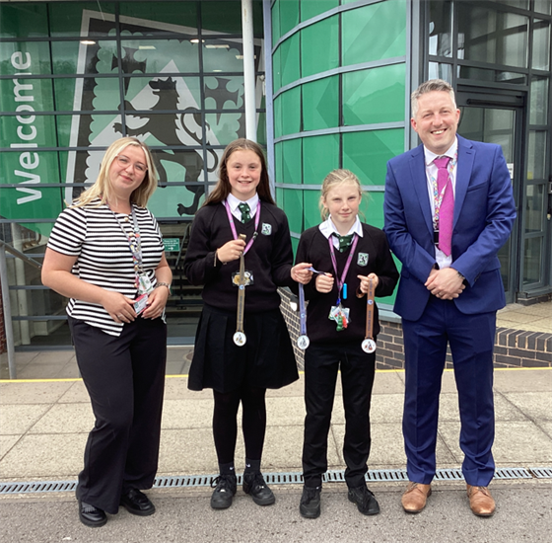

Wolves Football Club Star - Raheem S
We are delighted to share with you that Raheem S (Year 7) who plays for Wolves Football Club regularly will be heading to Germany next Friday to take part in the at Ahlem Tournament in Dortmund over the weekend. Not only is Raheem playing but he's also been selected to captain his team. We're exceptionally proud of Raheem and wish him all the very best for the tournament and can't wait to hear all about it!

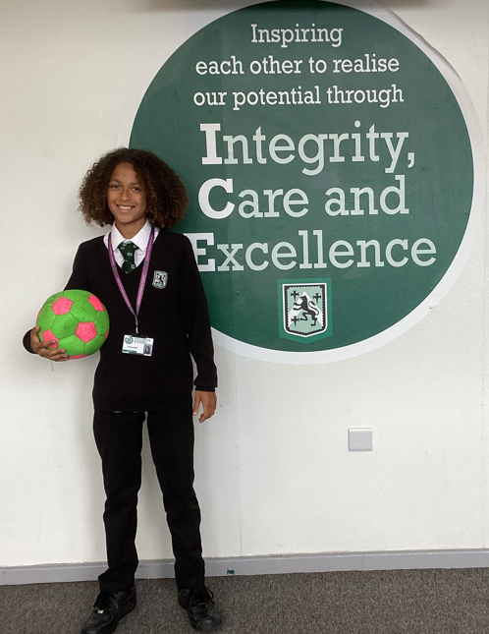
Sport
Rugby Coaching Festival
Well done to Year 8/ 9 boys involved in the Derby County Trust Rugby Coaching Festival. The boys planned and delivered sessions to over 500 primary school students at Rolls Royce rugby club. They all showed great leadership and integrity in representing Chellaston academy. Mr Warren would like to give a special to Gurmukh S and James B, they led brilliantly. Amazing work boys and well done!

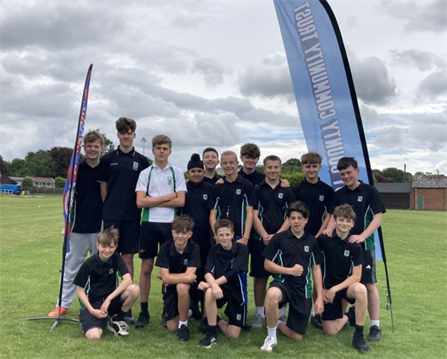

Dates for your diary
9th June - Year 12 UCAS trip
10th June - Battlefields Parents trip meeting
11th June - KS3 Fire Prevention Assemblies
11th June - Year 7 Parents evening
15th June - 26th June - Year 10 & 12 Mock exams
18th June - Year 11 Prom
19th & 20th June - Duke of Edinburgh Bronze Award practice expedition
22nd June - Year 8 HPV Vaccinations
22nd June - Year 10 Army Careers Talk
22nd June - Year 13 Prom
23rd June - SEND Year 6 to 7 Transition Day
29th June - Year 11 to 12 Transition Day
29th & 30th June - Year 12 Geography Field trip
3rd July - Year 10 Geography Field trip
7-9th July - Year 6-7 Transition Days
10th July - Sports Day
13th-17th July - Year 12 Work Experience
15th-17th July - Battlefields trip
22nd July - Rewards Day 3
23rd July - Break up for Summer Holidays

Kind regards,
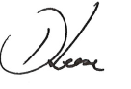
Mr. D Leese
Headteacher

